Batch: B2 Roll No.: 16010121200

Experiment No. 01

Grade: AA / AB / BB / BC / CC / CD /DD

Signature of the Staff In-charge with date

TITLE: Exploring basic Commands of UNIX: Shell, Processes, Files
_____________________________________________________________________

AIM: To Explore basic commands for handling File system under Unix/Linux using shell scripts.(Creating groups, chown , chmod , directory name, tty , diff, umask).
______________________________________________________________________
Expected Outcome of Experiment:

CO 1. To introduce basic concepts and functions of operating systems.
_____________________________________________________________________
Books/ Journals/ Websites referred:

- Silberschatz A., Galvin P., Gagne G. “Operating Systems Principles”, Willey Eight edition.
- Achyut S. Godbole , Atul Kahate “Operating Systems”, McGraw Hill Third Edition.
- Sumitabha Das “UNIX Concepts & Applications”, McGraw Hill Second
Edition.
_____________________________________________________________________
Pre Lab/ Prior Concepts:
An operating system (OS) is a resource manager. It takes the form of a set of software routines that allow users and application programs to access system resources (e.g. the CPU, memory, disks, modems, printers network cards etc.) in safe efficient and abstract way.
- The operating system kernel is in direct control of the underlying hardware. The kernel provides low-level device, memory and processor management functions (e.g. dealing with interrupts from hardware devices, sharing the processor among multiple programs, allocating memory for programs etc.)
- Basic hardware-independent kernel services are exposed to higher-level programs through a library of system calls (e.g. services to create a file, begin execution of a program, or open a logical network connection to another computer).
- Application programs (e.g. word processors, spreadsheets) and system utility programs (simple but useful application programs that come with the operating system, e.g. programs which find text inside a group of files) make use of system calls. Applications and system utilities are launched using a shell (a textual command line interface) or a graphical user interface that provides direct user interaction.
Operating systems can be distinguished from one another by the system calls, system utilities and user interface they provide, as well as by the resource scheduling policies implemented by the kernel.
UNIX has been a popular OS for more than two decades because of its multi-user, multi-tasking environment, stability, portability and powerful networking capabilities.
Linux is a free open source UNIX OS for PCs.
Linux has all of the components of a typical OS :
- Kernel
The Linux kernel includes device driver support for a large number of PC hardware devices (graphics cards, network cards, hard disks etc.), advanced processor and memory management features, and support for many different types of file systems. In terms of the services that it provides to application programs and system utilities, the kernel implements most BSD and SYSV system calls, as well as the system calls described in the POSIX.1 specification.
The kernel (in raw binary form that is loaded directly into memory at system startup time) is typically found in the file /boot/vmlinuz, while the source files can usually be found in /usr/src/linux.
- Shells and GUIs
Linux supports two forms of command input: through textual command line shells similar to those found on most UNIX systems (e.g. sh - the Bourne shell, bash - the Bourne again shell and csh - the C shell) and through graphical interfaces (GUIs) such as the KDE and GNOME window managers.
- System Utilities
Virtually every system utility that you would expect to find on standard implementations of UNIX has been ported to Linux. This includes commands such as ls, cp, grep, awk, sed, bc, wc, more, and so on. These system utilities are designed to be powerful tools that do a single task extremely well (e.g. grep finds text inside files while wc counts the number of words, lines and bytes inside a file). Users can often solve problems by interconnecting these tools instead of writing a large monolithic application program.
- Application programs
Linux distributions typically come with several useful application programs as standard. Examples include the emacseditor, xv (an image viewer), gcc (a C compiler), g++ (a C++ compiler), xfig (a drawing package), latex (a powerful typesetting language) and soffice (StarOffice, which is an MS-Office style clone that can read and write Word, Excel and PowerPoint files).
______________________________________________________________________
Description of Commands and options:

DOS commands: Attrib, dir, at, chkdsk, shutdown, tree, create a batch file, output and input redirection

Windows utilities: msconfig, defragmenter, performance monitor, task manager, registry editor, event viewer, process explorer

Unix Commands:

- Unix file operations: ls, cp, rm , mv, chmod, chown ,chgrp
- Text file operations in Unix: cat , more , less , head, tail , grep
- Unix directory management commands: cd, pwd , ln, mkdir, rmdir
- Unix system status commands: hostname, w, uname ,utime
- Process management: ps, top, kill,nice
- Unix users commands: whoami , id, groups, passwd , who, last

Implementation details:
Unix commands:
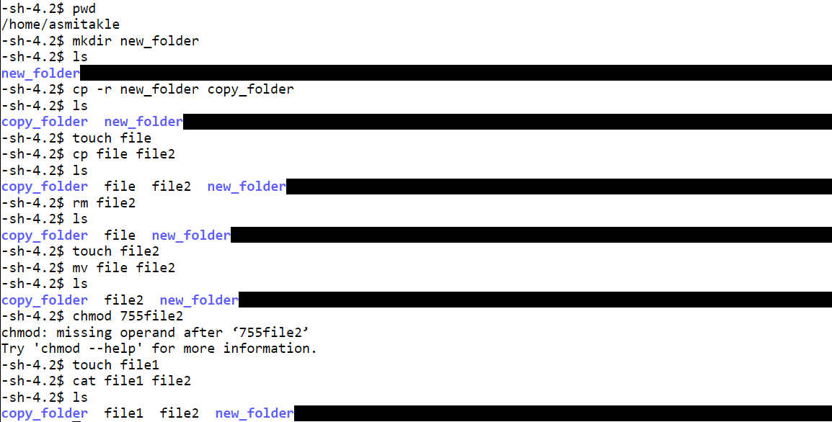
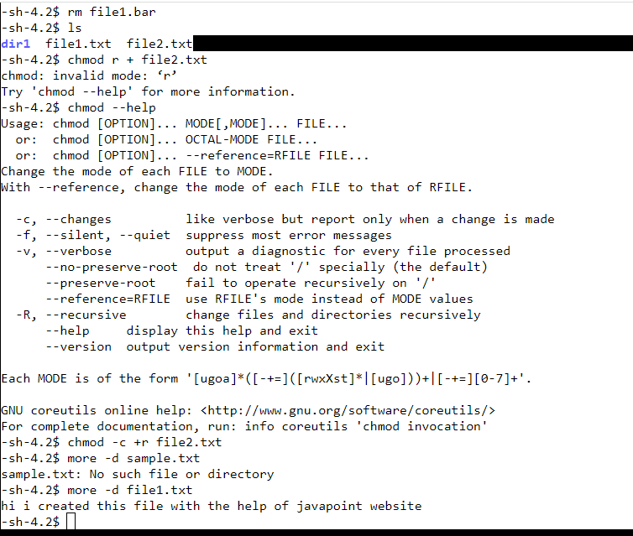
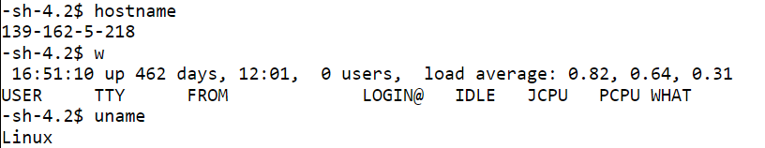
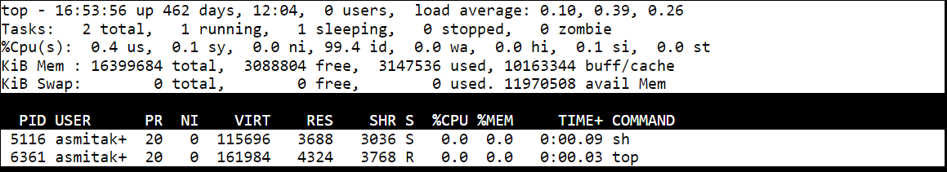
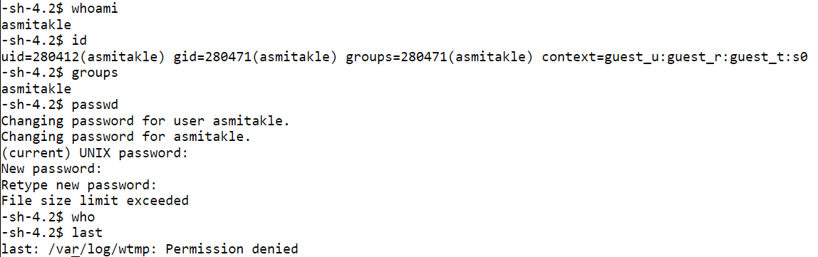
Windows utilities:
msconfig:
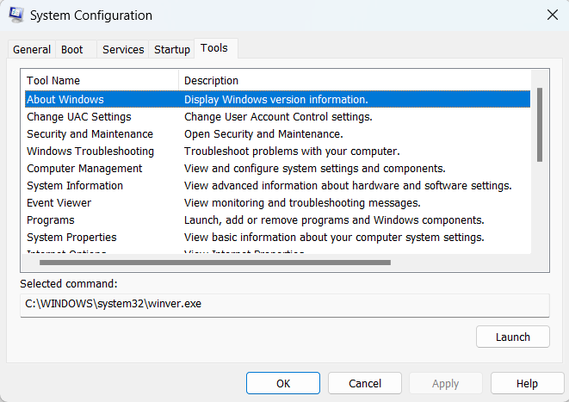
Performance monitor:
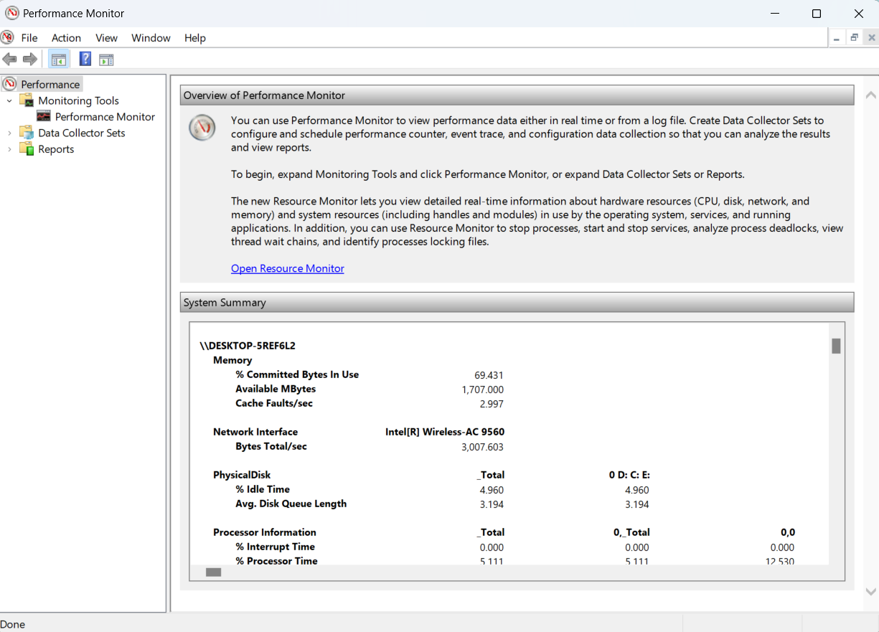
Task manager:
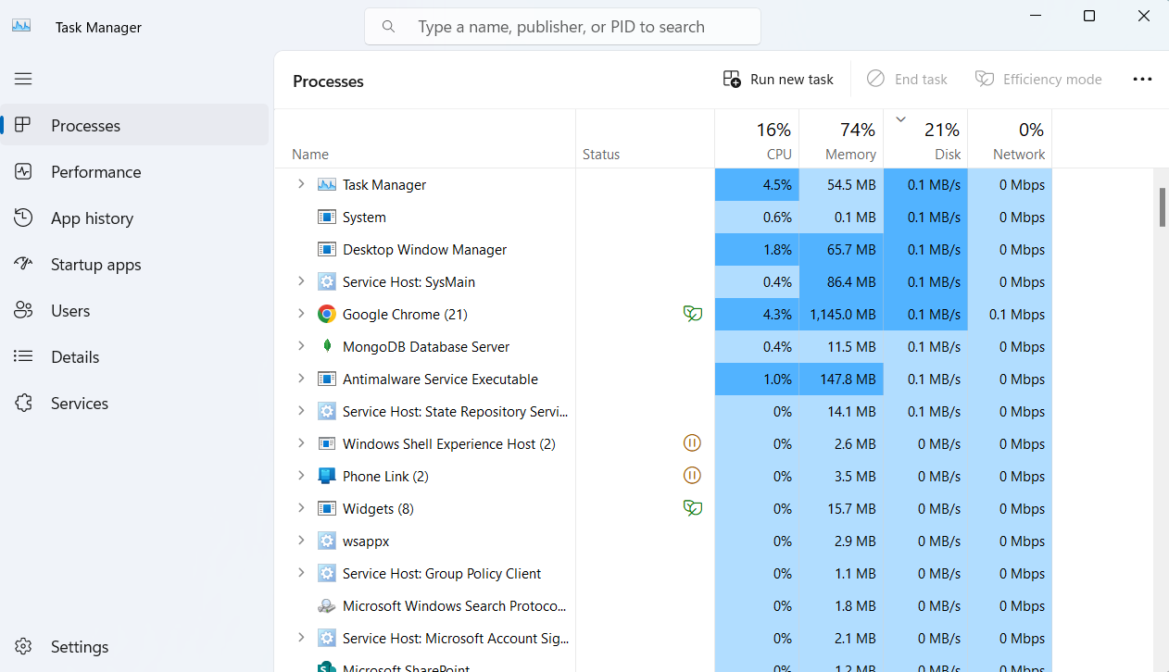
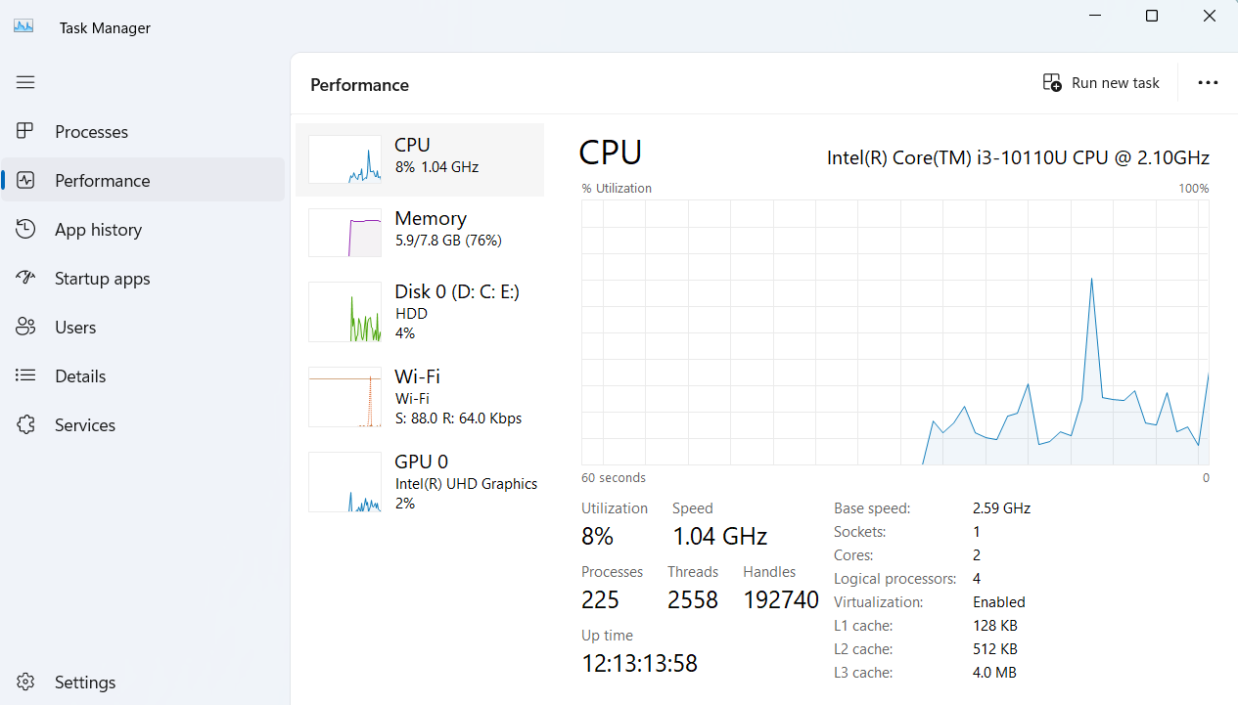
Windows batch file:
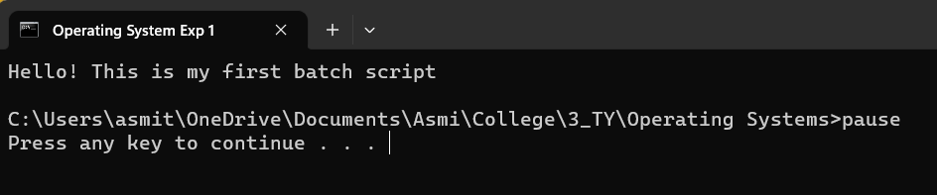
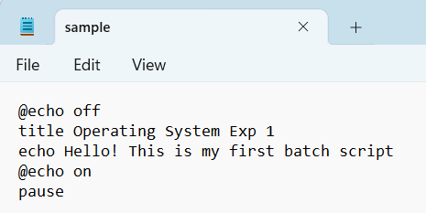
Conclusion:
Explored basic commands in Unix/Linux and understood the use of windows utility tools.
Post Lab Descriptive Questions

- Explain how do you read and interpret syntax of any OS command.

Reading and interpreting the syntax of an OS command involves understanding its structure and components. A command typically starts with a keyword, followed by options, arguments, and flags. Referencing command-line manuals provides details on available options. Interpreting syntax entails recognizing the order and format of these elements. For instance, in the command `ls -l /path/to/directory`, "ls" is the command, "-l" is an option, and "/path/to/directory" is an argument.

- Explain different functions of the operating systems.

Operating systems serve various functions. They manage processes, memory, files, devices, security, and user interfaces. They facilitate software-hardware interaction, resource utilization, and networking.

- What are the default permissions assigned by Unix for Directory.

Unix assigns default directory permissions as 755. This means the owner has read, write, and execute (7) permissions, while group and others have read and execute (5) permissions. Owners can modify, while others can navigate.

- Give the difference between DOS and WINDOWS.

DOS is a command-line OS; Windows is a GUI-based OS. Windows offers multitasking, hardware support, and a visual interface, while DOS relies on text commands and has limited features.

- Explain Booting Process.

Booting starts a computer. After powering on, it undergoes POST, loads firmware (BIOS/UEFI), loads the boot loader, starts the OS kernel, initializes processes and drivers, and presents the user interface.

Date: _____________ Signature of faculty in-charge

